
Lesson 5 Teacher's Key
TIC-80
INSTRUCTOR ONLY - do not distribute to students

Level 1 - Complete Worked Solution
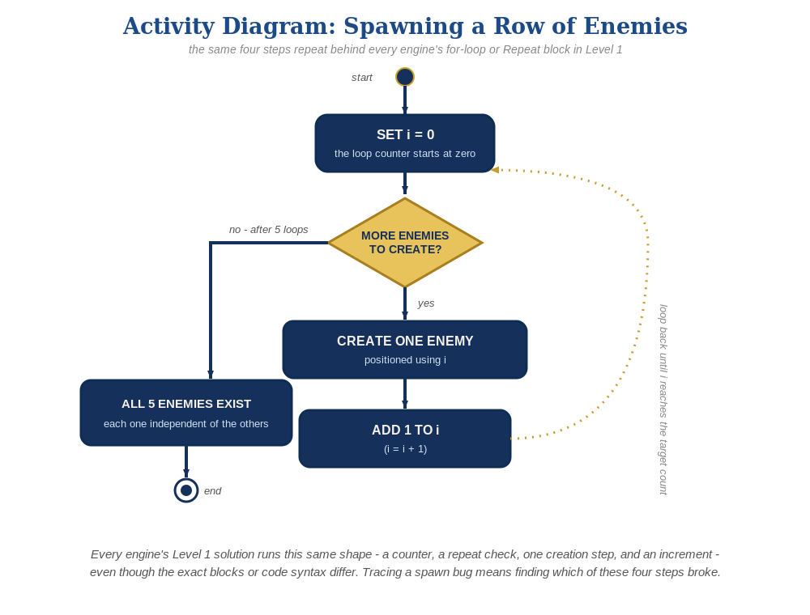
The spawn loop, in general - the same counter, repeat check, creation step, and increment behind Level 1 in every engine, whatever the exact blocks or syntax look like.
An enemies table populated by a for loop at startup, plus a nested loop inside the existing bullets loop:
enemies={}
for enemy_count=0,4 do
table.insert(enemies,{ex=20+enemy_count*20,ey=10,alive=true})
end
bullets={}
function TIC()
cls(0)
if btn(3) then x=x+1 end
if btnp(4) then
table.insert(bullets,{bx=x,by=y})
end
for i=#bullets,1,-1 do
local b=bullets[i]
b.by=b.by-2
local hit=false
for j=1,#enemies do
local e=enemies[j]
if e.alive and b.bx<e.ex+8 and b.bx+8>e.ex and b.by<e.ey+8 and b.by+8>e.ey then
e.alive=false
hit=true
end
end
if hit then
table.remove(bullets,i)
elseif b.by<0 then
table.remove(bullets,i)
else
spr(2,b.bx,b.by,0)
end
end
for j=1,#enemies do
local e=enemies[j]
if e.alive then spr(3,e.ex,e.ey,0) end
end
spr(1,x,y,0)
end

Level 2 - Complete Worked Solution
The inner enemies loop checks every enemy for every bullet, every frame, so this naturally scales to any number of enemies with no extra code - a hit sets e.alive=false for exactly the one enemy whose bounds actually overlapped that bullet.

Level 3 - All Worked Solutions
Every stretch-goal idea from the handout, fully worked - not just one. Useful for validating each idea actually works before class, and as a ready reference no matter which one a student ends up picking.

Sound: already works
sfx(2) can stay exactly where it was added in Lesson 4's hit branch - add it inside the hit=true assignment if not already there:
if e.alive and b.bx<e.ex+8 and b.bx+8>e.ex and b.by<e.ey+8 and b.by+8>e.ey then
e.alive=false
hit=true
sfx(2)
end

Visual: row variety
Use each enemy's index j to flip alternating enemies for a bit of visual variety:
for j=1,#enemies do
local e=enemies[j]
if e.alive then spr(3,e.ex,e.ey,0,1,j%2) end
end

Structure: enemy state lives in the table
Every place that needs an enemy's position or status reads it from the enemies table - resist ever declaring a loose ex/ey/alive variable outside it again.

Complete Level 3 solution (all 3 goals combined)
Everything above combined into the one TIC() function:
enemies={}
for enemy_count=0,4 do
table.insert(enemies,{ex=20+enemy_count*20,ey=10,alive=true})
end
bullets={}
function TIC()
cls(0)
if btn(3) then x=x+1 end
if btnp(4) then
table.insert(bullets,{bx=x,by=y})
end
for i=#bullets,1,-1 do
local b=bullets[i]
b.by=b.by-2
local hit=false
for j=1,#enemies do
local e=enemies[j]
if e.alive and b.bx<e.ex+8 and b.bx+8>e.ex and b.by<e.ey+8 and b.by+8>e.ey then
e.alive=false
hit=true
sfx(2)
end
end
if hit then
table.remove(bullets,i)
elseif b.by<0 then
table.remove(bullets,i)
else
spr(2,b.bx,b.by,0)
end
end
for j=1,#enemies do
local e=enemies[j]
if e.alive then spr(3,e.ex,e.ey,0,1,j%2) end
end
spr(1,x,y,0)
end

